**Lions International District 306 C1**

**Region 6A Zone 01**

 **Lions club Kandy Senkadagala**  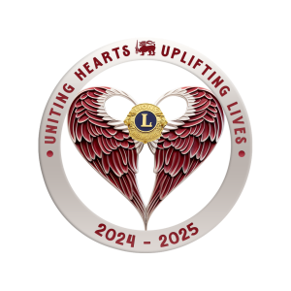

🌟 Another Humanitarian Project by Lions Club of Kandy Senkadagala (LCKS) 🌟

On 16th July, we successfully donated an electrically operated patient bed and three armchairs to the Cancer Society, Kandy branch. This generous donation was made by Mr. Ahimtha Kandamey and his family from the USA during their short visit. Additionally, we provided fruits and yogurts to the patients.

Project Chairman: Lion Padma Jayawardena

Coordinator: Lion Sivaraj Malgudi

LCKS President Lion Rengasamy Chandran, Treasurer Lion Srilal Mendis, Lion Priyantha Abyaratna, Lion Dileepa Jayasundara, Lion Indu Imbulagoda, Lion Padma Jayawardena and her family, Lion Lady Chandran Krishanthi, participated in this Humanitarian Project.

The total project cost is approximately LKR 300,000.00.

Thank you to all involved for their dedication and support! Together, we make a difference. 🙌

#Lions Club of Kandy Senkadagala

#Humanitarian Project

#Community Service