**Lions International District 306 C1**

**Region 6A Zone 01**

 **Lions club Kandy Senkadagala**  

**On August 21st,the Lions Club of Kandy Senkadagala made it mark by organizing a diabetic awareness program led by President Lion Rengasamy Chandran at his shop. Nearly 100 community members were tested for diabetes, making a significant contribution to public health.**

**We extend our gratitude to the dedicated Lions who participated and contributed:**

**- Lion Swarnee Pathirana, Lion Padma Jayawardena, Lion Austin Siriwardena,Lion Rosani Jennifer, Lion Srilal Mendis**

**Lion Lady Krishanthi**

**A special thank you to Mr. Barathan, who represented the glucometer supplier and helped ensure the success of the testing.**

**Together, the Lions Club of Kandy Senkadagala continues to "Make Our Mark" by enhancing our community's health and well-being!**

**BILL**

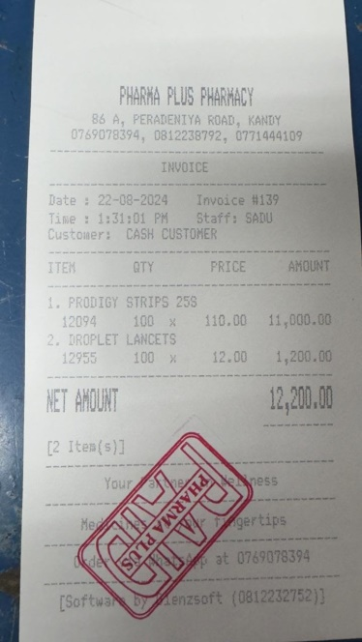

**Lion Participation**

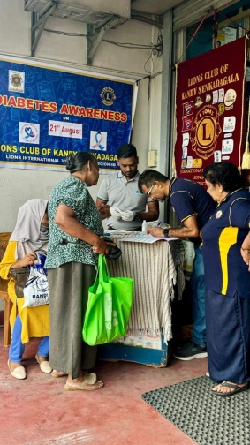 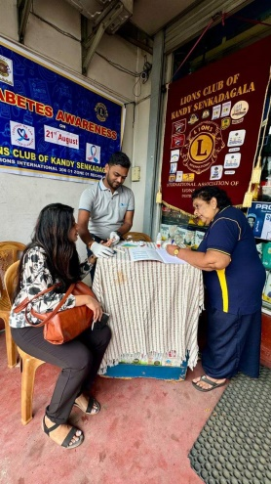 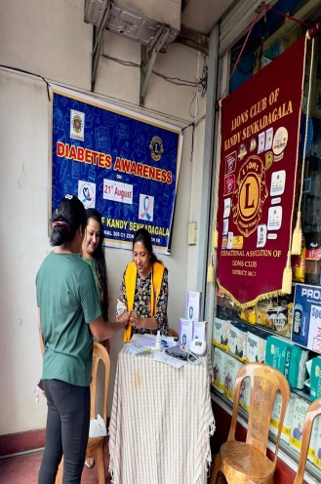 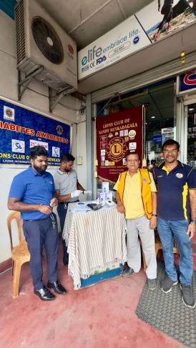 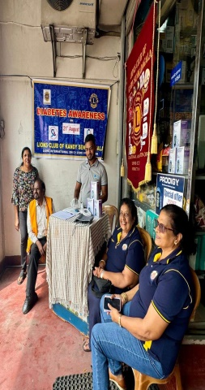

**Participation of people**

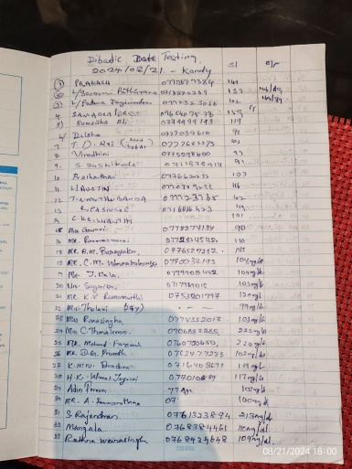 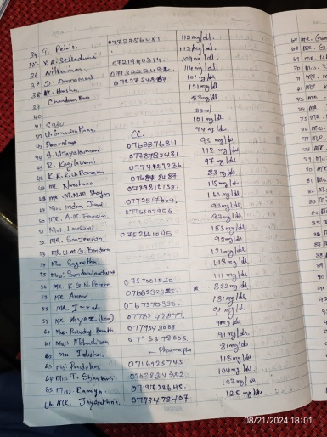 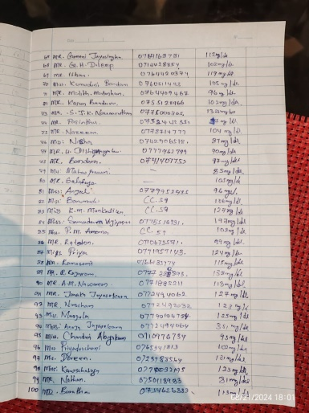

**Facebook Update**

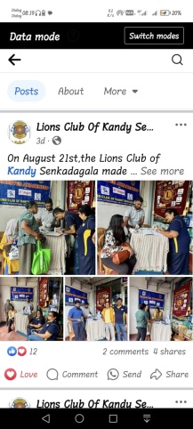

**Lion International reporting**

