LIONS CLUB OF KANDY SENKADAGALA

PROJECT REPORT

Project Title:

Empowering Education at the Senkadagala Special School

Project Chairperson: Lion Vidyamali Samarasinghe

Date of Project:

8th January 2025

Venue:

Senkadagala Special School, Dodamwala, Kandy

Project Overview:

The Lions Club of Kandy Senkadagala successfully carried out an impactful community service project focused on enhancing educational infrastructure for students with special needs. The project involved the donation of book racks to the Senkadagala Special School, benefiting students with hearing impairments and other special requirements.

Project Sponsor:

This project was made possible through the generous sponsorship by the family of the late Lion Prof. Stanley (Sam) Samarasinghe, in loving memory of his dedication to education and community service.

Value of the Project:

LKR 292,000.00

Special Guests:

Lion Vidyamali Samarasinghe

Mr. Mevan Samarasinghe

Mrs. Erin Samarasinghe

(The family traveled from the United States to be a part of this special occasion.)

Event Highlights:

A colorful traditional dance performance was showcased by the students of the school, highlighting their talents and cultural appreciation.

Club members wore custom-designed T-shirts made by the school as a sign of unity and support for their vocational training efforts.

The interaction between Lions members and the school community fostered deeper engagement and support for inclusive education.

Impact:

This initiative has not only contributed to improving the learning environment but also underscored the importance of inclusion, empowerment, and cultural pride. The book racks will support better organization and accessibility of learning materials for the students.

Remarks:

This meaningful project reaffirmed the Lions Club's commitment to serving with compassion and creating long-term positive change in the community. The presence of the donor family added emotional significance to the event, reflecting the deep connections between service, memory, and legacy.

Photo Documentation:

[Attach photos of the event, book rack donation, guest participation, dance performance, and group photos]

This project was approved by the board

 

................................... ..............................................

President Secretary

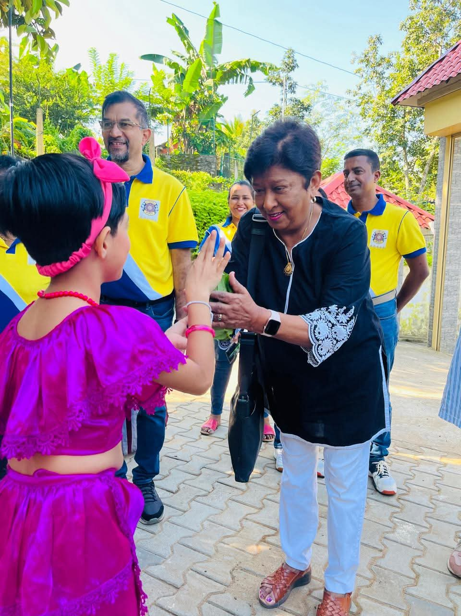

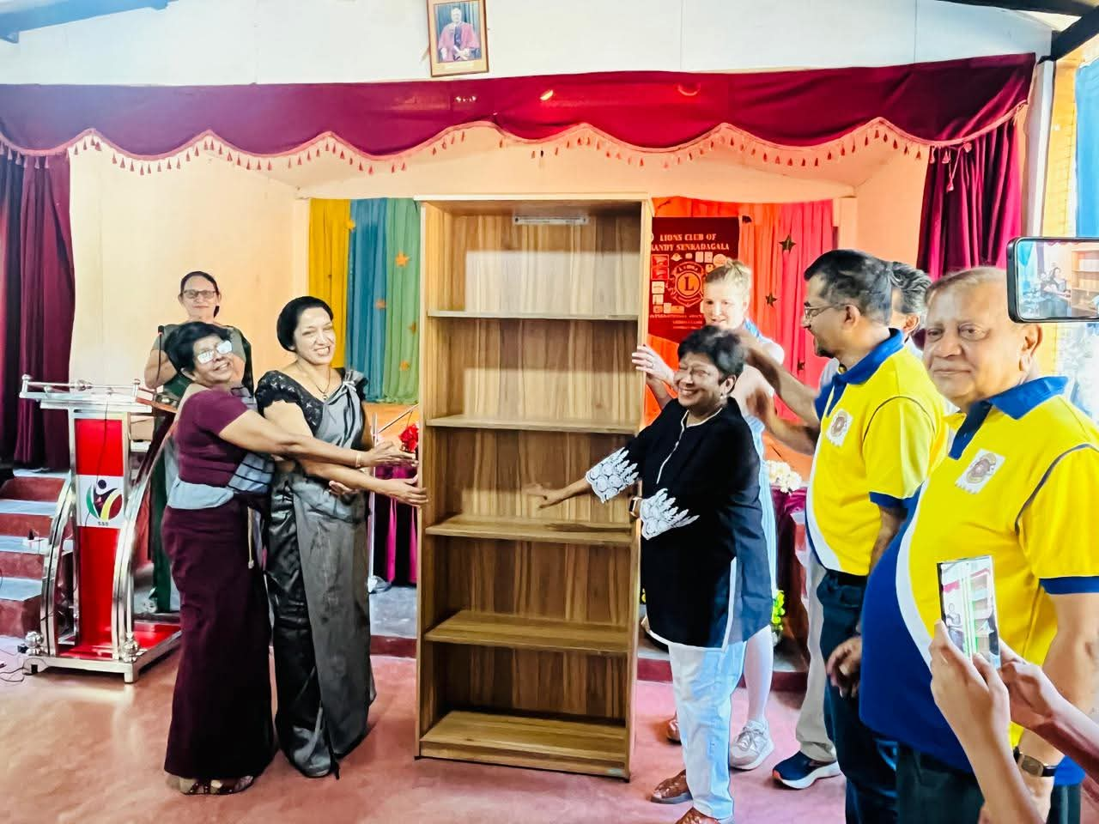 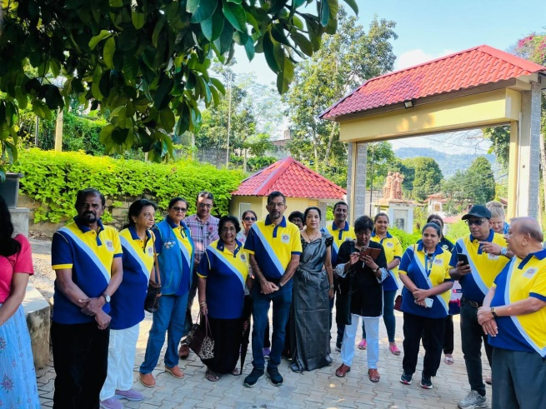

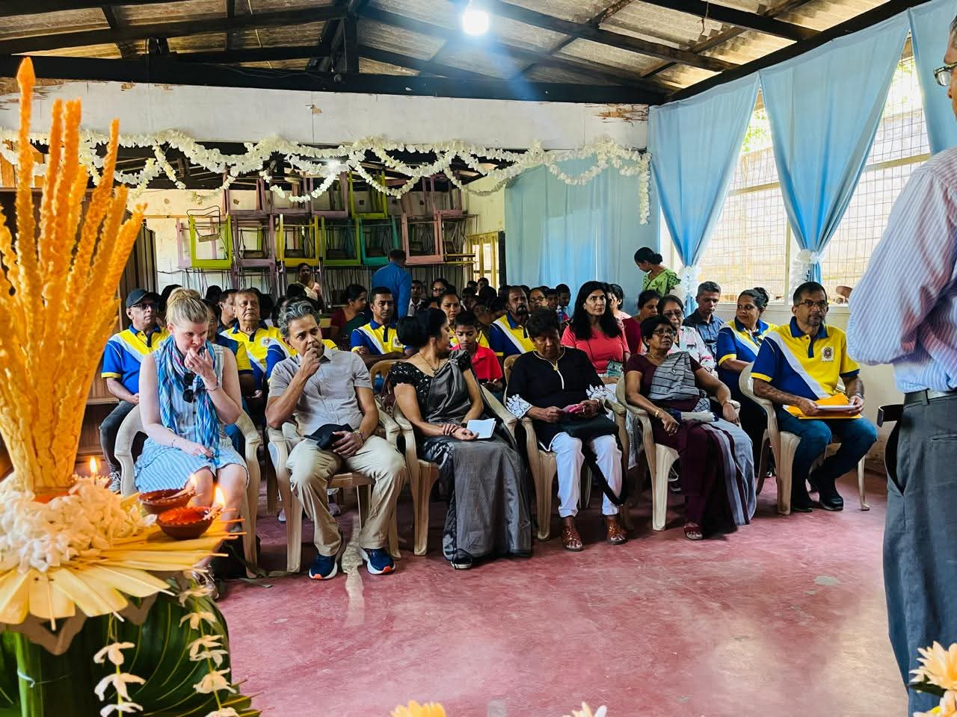 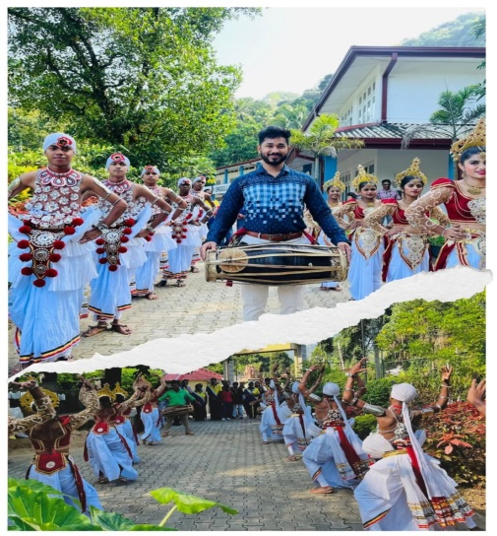

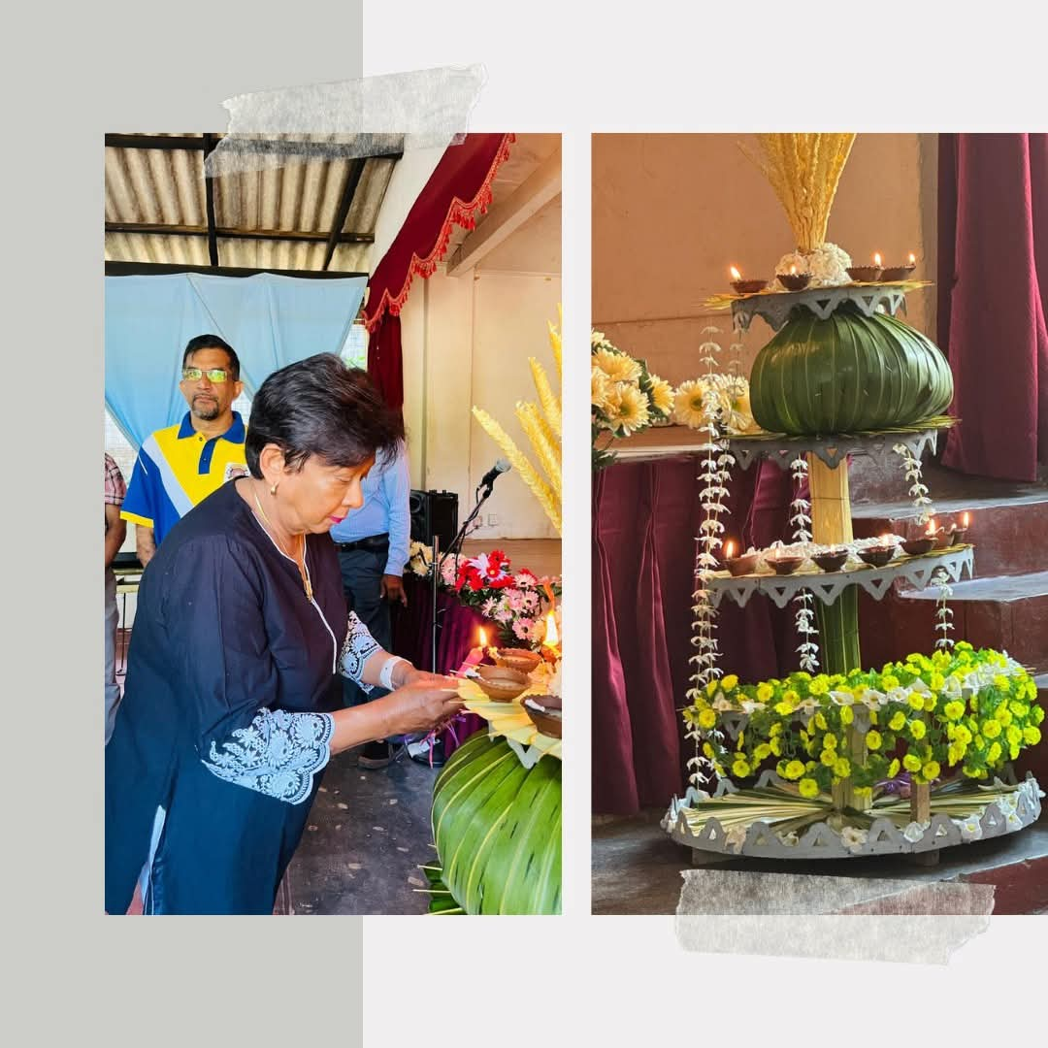 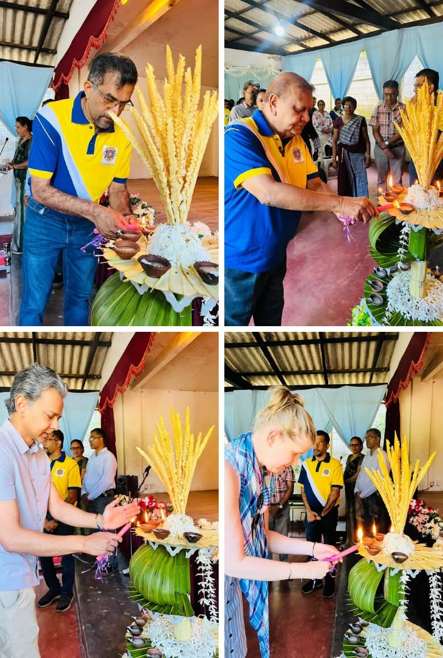

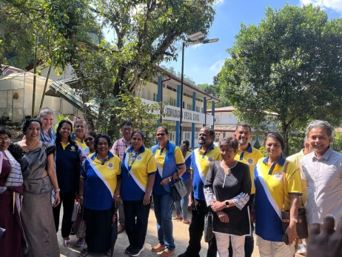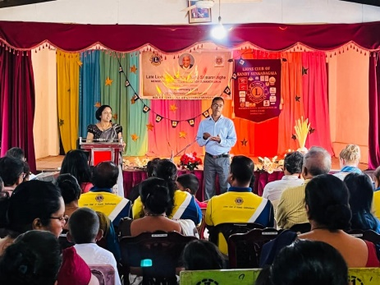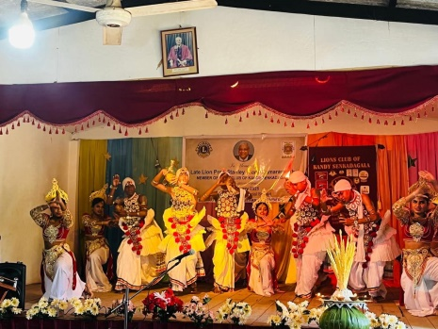

Prepared By:

Lion Kamal Abeykoon –Club Secretary

Lions Club of Kandy Senkadagala

Date of Report: 08-01-2025