Lions Club of Kandy Senkadagala

Project Plan Report

Project Title: Empowering Abilities through Collaboration

Project Date: 18-12-2025

Location: K/Senkadagala Special School, Dodamwala, Kandy

1. Project Objective

To support and empower students with speech impairments by providing them an opportunity to apply their vocational skills in designing and producing T-shirts for Lions Club members, while fostering inclusivity and collaboration.

2. Project Scope

Collaborate with the special school to design and manufacture custom T-shirts.

Engage club members in the initiative to build awareness and promote inclusive community partnerships.

Promote the talents and capabilities of differently-abled students.

3. Beneficiaries

Students with speech impairments at K/Senkadagala Special School.

Lions Club members who received custom T-shirts and supported the cause.

The community, by raising awareness of the abilities of differently-abled individuals.

4. Key Activities-

Completing a lions club T shirt.

5. Project Budget

Total Cost: Rs. 75,000

Funding Source: Lions Club of Kandy Senkadagala

6. Project Chairman

Name: Lion Rengasamy Chandran

7. Outcomes & Impact

Empowered students by offering real-world application of their skills.

Fostered stronger ties between the club and the local special needs community.

Promoted inclusivity and recognized the potential in individuals with speech impairments.

Positive engagement of club members in a meaningful initiative.

8. Photos & Media

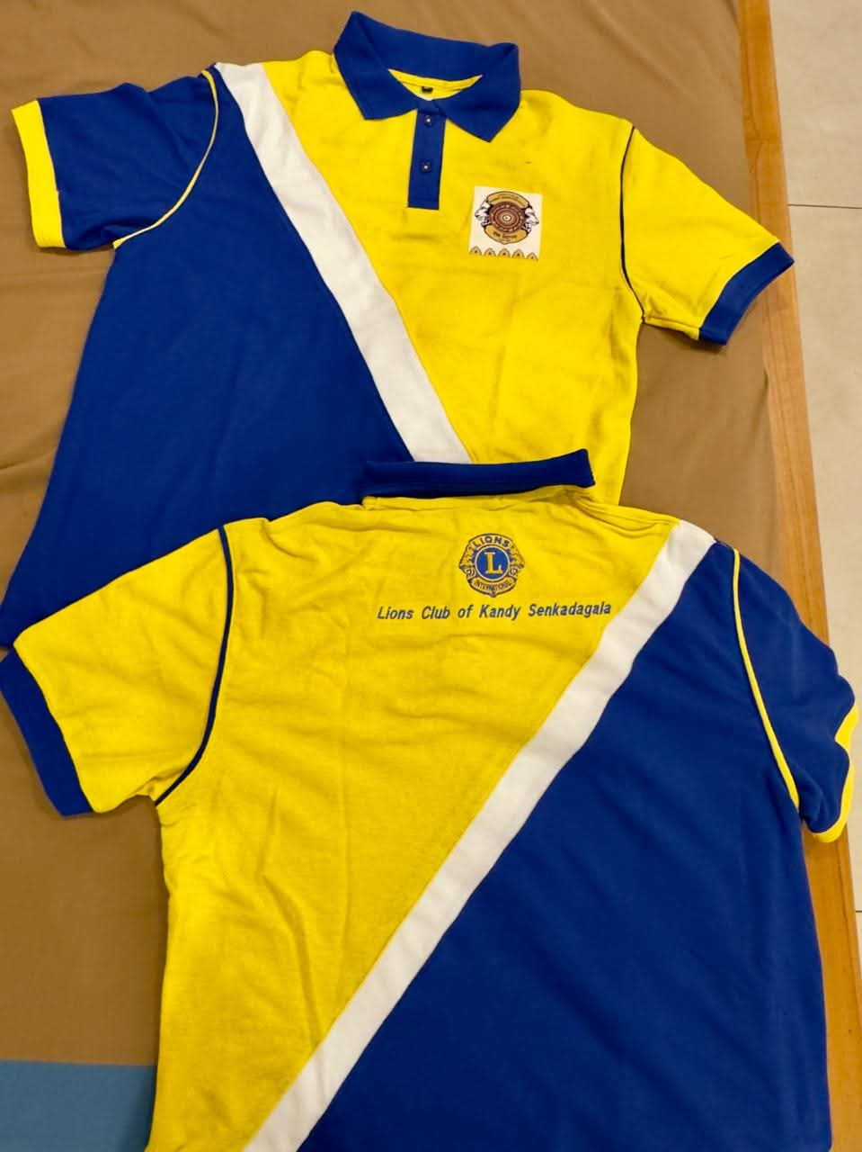 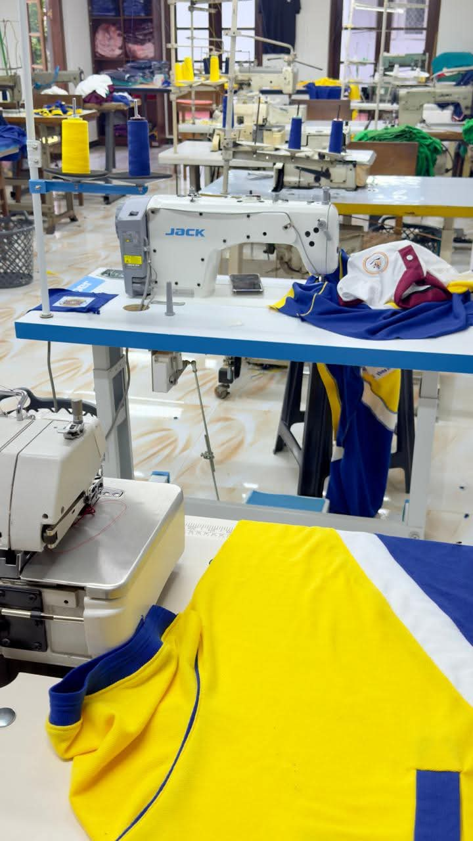

Prepared By:

Lion Kamal Abeykoon –Club Secretary

Lions Club of Kandy Senkadagala

Date of Report: 08-01-2025

This project was approved by the board

 

................................... ..............................................

President Secretary