Lions Club of Kandy Senkadagala

Project Report

Title: Supporting Local Entrepreneurship – Name Board for Gardener's Stall

Project Chairman: Lion Indu Imbulagoda

Date of Project: 23-01-2025

Project Location: 76/1, Kandy Road, Kengalla

Objective:

To support a local gardener by enhancing his business visibility through the installation of a professionally made name board at his stall, thereby promoting local entrepreneurship and community development.

Project Description:

As part of the Lions Club of Kandy Senkadagala's (LCKS) continued commitment to humanitarian service and economic empowerment, the club funded and facilitated the installation of a name board for a local gardener’s business in Kengalla. This initiative is expected to boost his visibility and improve customer engagement, contributing to the growth of his small enterprise.

Total Project Cost:

LKR 23,000.00

Participating Members:

Lion Rengasamy Chandran – President, LCKS

Lion Sivaraj Mankudi

Lion Priyantha Abayaratna

Lion Austin Siriwardena

Lion Padma Jayawardena

Lion Indu Imbulagoda

Outcome & Impact:

Lion Image Building

Enhanced visibility for the gardener’s business

Encouragement and support for local entrepreneurship

Strengthened community connection and goodwill

Remarks:

The Lions Club of Kandy Senkadagala recognizes that empowering local businesses, even though small contributions, can create lasting impacts. This project aligns with the club’s mission to serve and uplift communities through practical and meaningful initiatives.

Prepared by:

Lion Kamal Abeykoon

Secretary

Lions Club of Kandy Senkadagala

Date: 29-01-2025

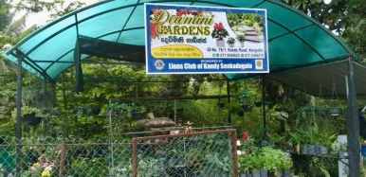 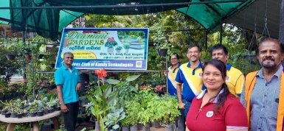 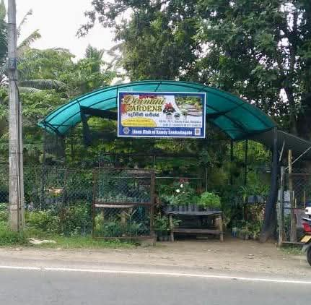 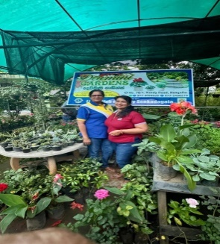

This project was approved by the board

 

................................... ..............................................

President Secretary