Lions Club of Kandy Senkadagala

Project Report – Wheelchair Donation

Project Title:

Supporting Our Community – Wheelchair Donation to a 93-Year-Old Mother

Project Date:

14th September 2024

Project Description:

In alignment with our mission to serve and uplift our community, the Lions Club of Kandy Senkadagala donated a wheelchair to a 93-year-old mother in need. This initiative was carried out in response to a request made by her son, showcasing our commitment to compassion and timely support for the elderly and differently-abled.

Beneficiary:

A 93-year-old mother residing within our community.

Total Project Cost:

Rs. 24,000

Project Chairman: Lion Priyantha Abayaratna

Participating Lions:

Lion Priyantha Abayaratna

Lion Kamal Abeykoon

Lion Raj Manikam

Lion Menaka Herath

Remarks:

This project reflects our club’s continued dedication to community welfare. The heartfelt appreciation from the family of the recipient is a testament to the impact of our service.

Conclusion:

By identifying the needs of our community and acting promptly, the Lions Club of Kandy Senkadagala continues to uphold the true spirit of Lionism — “We serve.”

Prepared by:

Lion Kamal Abeykoon

Secretary

Lions Club of Kandy Senkadagala

Date: 14-09-2024

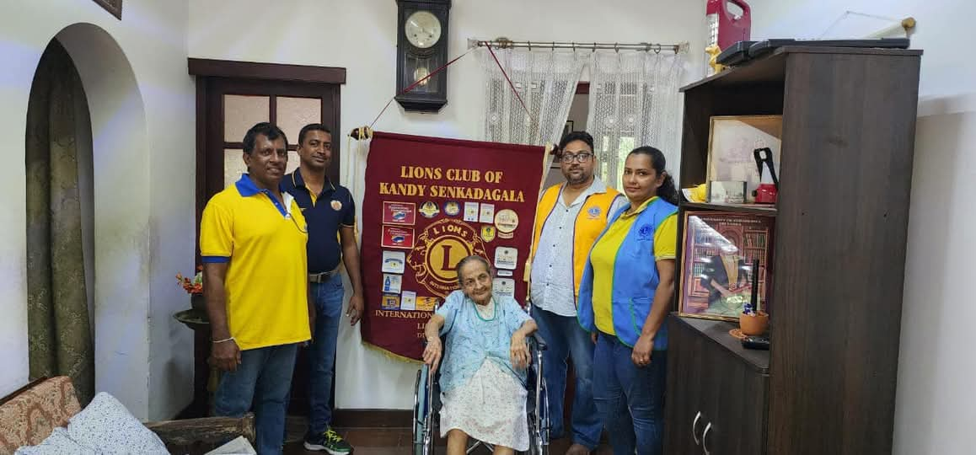 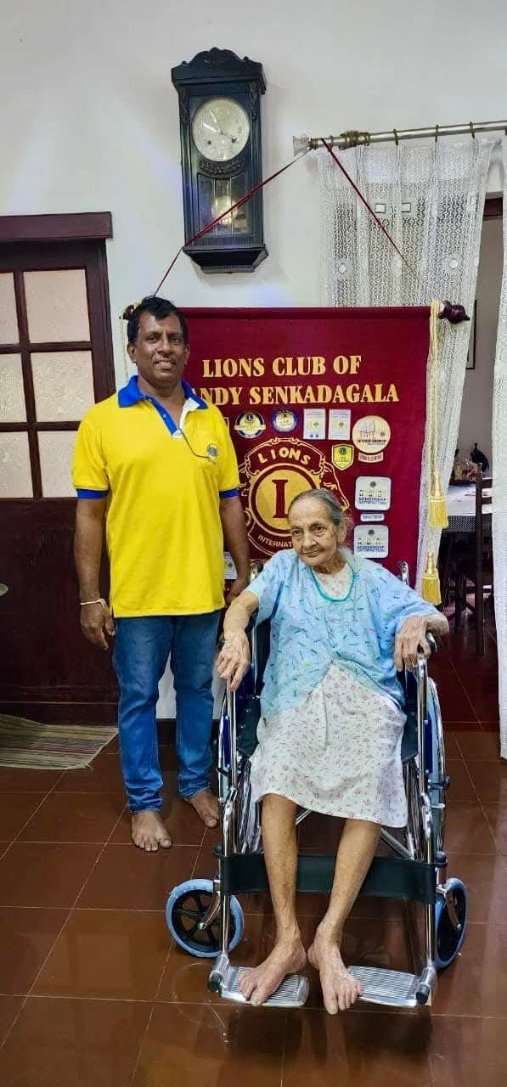

This project was approved by the board

 

................................... ..............................................

President Secretary