Project Report: Elderly Caring Service Project – Warapitiya Elderly Home

Lions Club of Kandy Senkadagala (LCKS)

Date: 3rd October 2024

Venue: Elderly Home, Warapitiya, Teldeniya

Project Title: Elderly Caring Service Project – Dry Ration Donation & Support

Project Chairpersons: Lion Indu Imbulagoda & Lion Rengasamy Chandran

Objective:

To provide essential support and care to the elderly residents of the Warapitiya Elderly Home by supplying urgently needed dry rations, serving meals, and offering personal grooming services to enhance their wellbeing.

Project Description:

The Lions Club of Kandy Senkadagala (LCKS) conducted a heartfelt Elderly Caring Service project on 3rd October 2024 at the Warapitiya Elderly Home, Teldeniya. This project was initiated in response to the pressing shortage of food supplies at the home.

As part of the service:

Dry rations were donated to help sustain the residents and support the home’s daily needs.

A nutritious breakfast was served to all the inmates, bringing comfort and care to their morning routine.

Haircuts were voluntarily offered to all the residents by Lion Indu Imbulagoda and her friend Chandima Lakmali, ensuring dignity and personal care.

Participants & Supporters:

Lion Indu Imbulagoda – Project Chairperson & Volunteer

Lion Rengasamy Chandran – LCKS President & Project Chairperson

Lion Srilal Mendis – LCKS Treasurer

Mrs. Chandrika and her husband – Friends of Lion Padma Jayawardhana, participated and contributed

Project Cost & Contributions:

Total cost of the project: LKR 30,000.00

Contributions were made by LCKS members and well-wishers involved in the project.

Impact:

Immediate relief was provided to the elderly residents through the donation of essential food items.

Residents felt valued and cared for through personal grooming and attentive service.

The project strengthened the Club’s commitment to elderly care and community service.

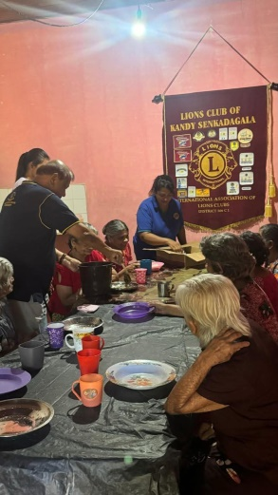 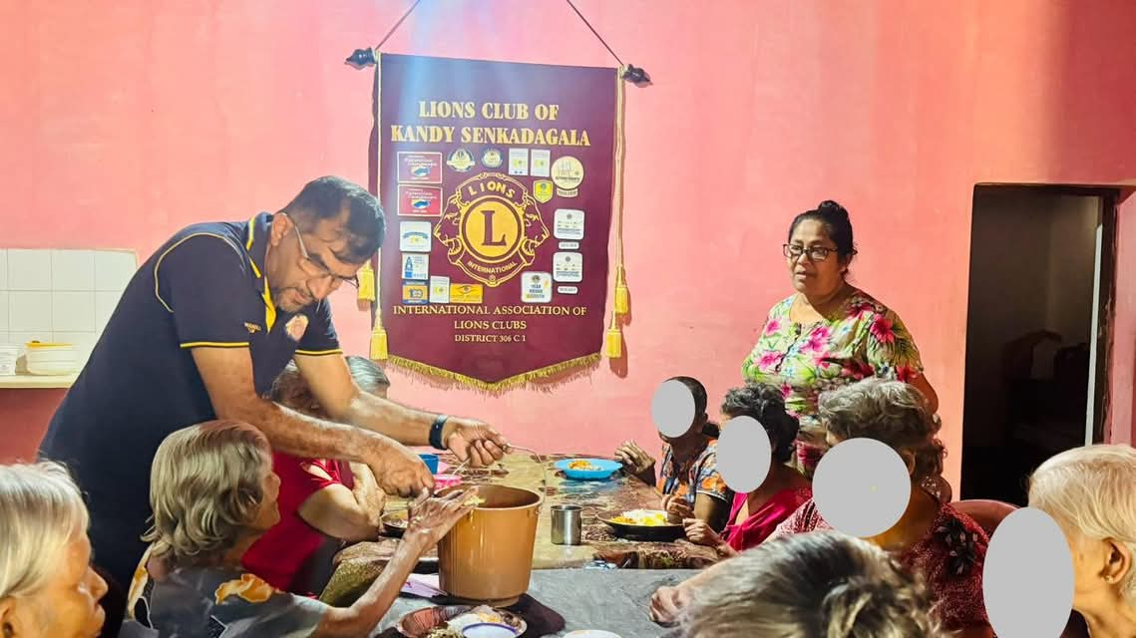

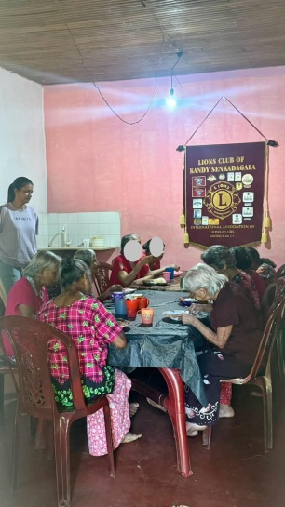 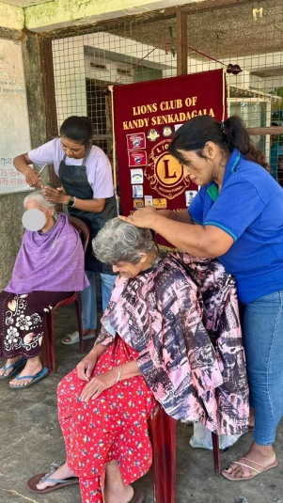 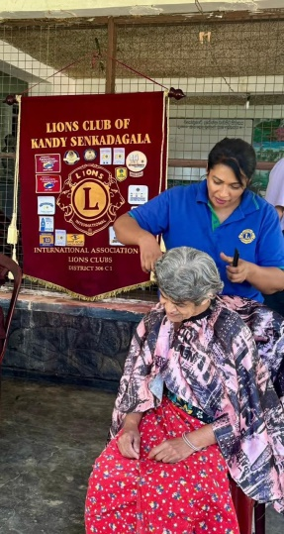

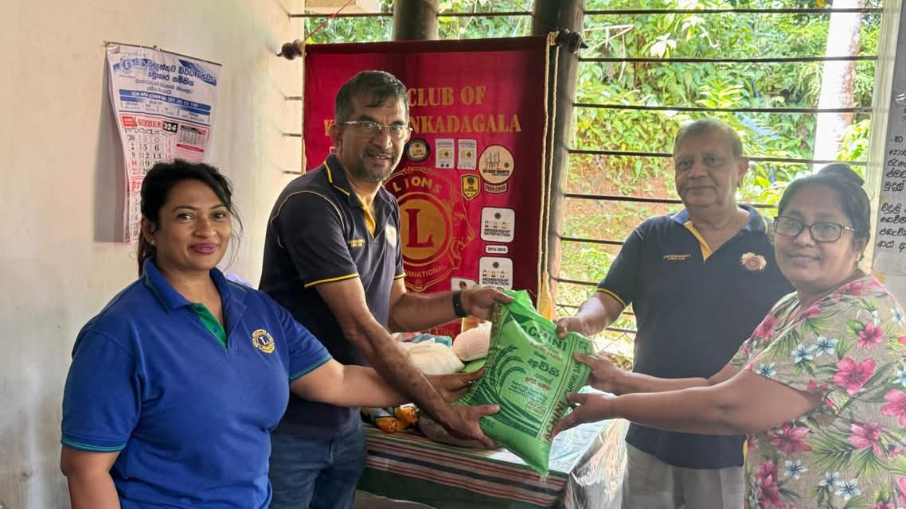

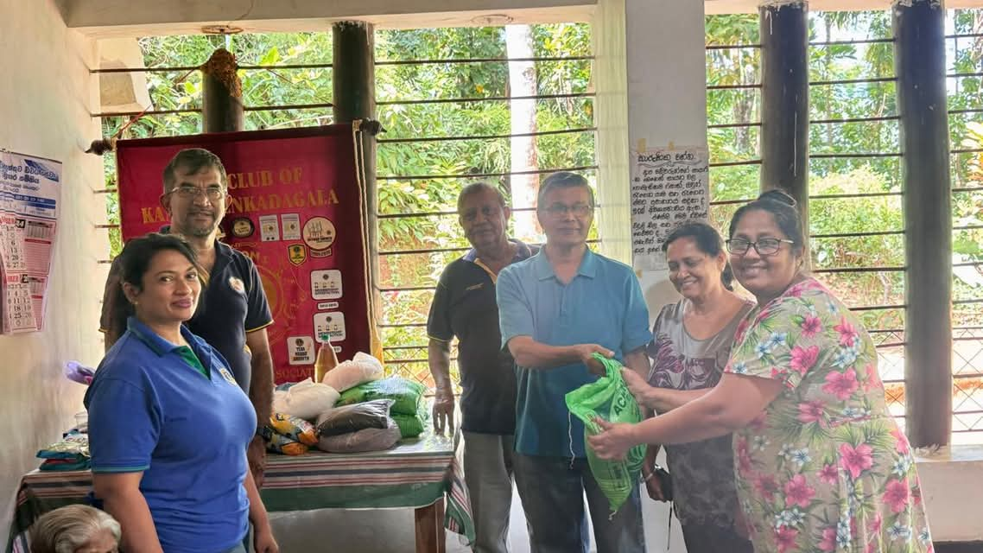

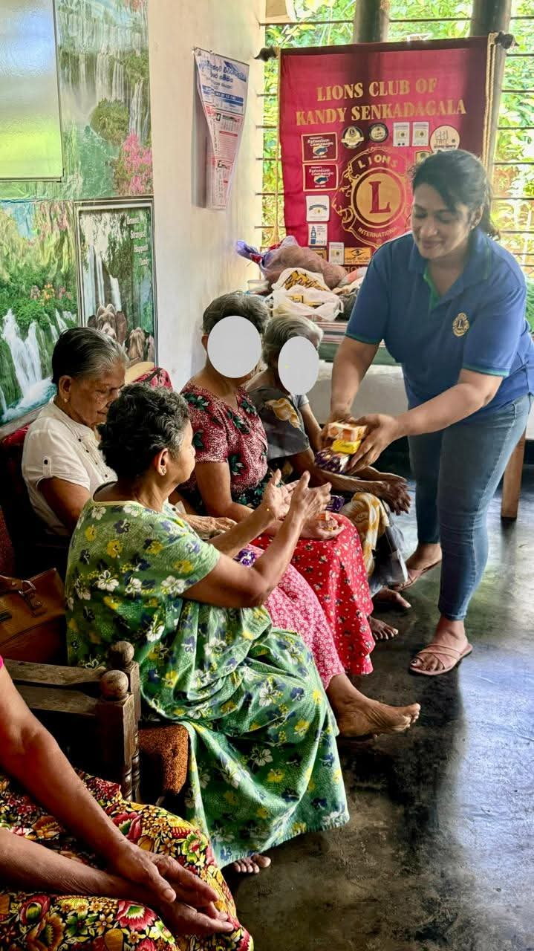

Prepared By:

Lion Kamal Abeykoon –Club Secretary

Lions Club of Kandy Senkadagala

Date of Report: 03-10-2024

This project was approved by the board

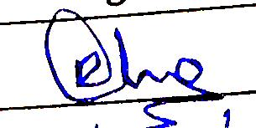 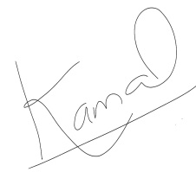

................................... ..............................................

President Secretary