Lions Club of Kandy Senkadagala

Project Report

Project Title: Diabetes Awareness Diabetes screening & Vision Care Camp

Date Conducted: 13th October 2024

Venue: St. Anthony’s Cathedral, Kandy

Project Chairman: Lion Austin Siriwardena

Reported by: Club Secretary, Lion Kamal Abeykoon

Project Cost: Rs. 65,000.00 club funds were taken for the project

Objective:

To raise awareness about diabetes and provide essential vision care services to underserved members of the community.

Project Summary:

The project was successfully conducted on 13th October 2024 at St. Anthony’s Cathedral, Kandy, with the support of parish authorities and enthusiastic volunteers. Free blood sugar screenings, vision tests, and educational sessions were provided to attendees.

Special Thanks:

Our heartfelt thanks to Rev. Fr. Sudath Perera, Parish Priest, for providing the venue and supporting this community initiative.

Lions Participated:

Lion Rengasamy Chandran , Lion Kamal Abeykoon, Lion Thushari Jayawardena, Lion Padma Jayawardena, Lion Raj Manikam, Lion Menaka Hearth, Lion Austin Siriwardena, Lion Indu Imbulagoda, Lion Priyantha Abayaratna, Lion Rosani Jennifer, Lion Lady Krishanthi, Lion Kamal’s Daughter Dewmini Abeykoon

Special Guests and Support:

Region Chairman Lion Kanchana Jayasinghe

Volunteers from the Joseph Vaz Society

Impact:

Over 150 individuals benefitted from diabetes screening and eye checkups.

Improved awareness on the importance of early detection and lifestyle changes.

Several follow-up recommendations were made for further medical assistance.

Conclusion:

This project was a meaningful step toward better health awareness in our community. The total cost incurred was Rs. 65,000.00, which covered all medical supplies, logistics, and refreshments. We thank everyone who contributed to making this initiative a success.

Submitted by:

Lion Kamal Abeykoon

Club Secretary

Date: 22-10-2024

This project was approved by the board

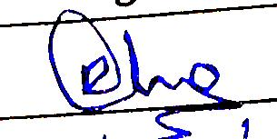 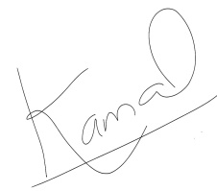

................................... ..............................................

President Secretary