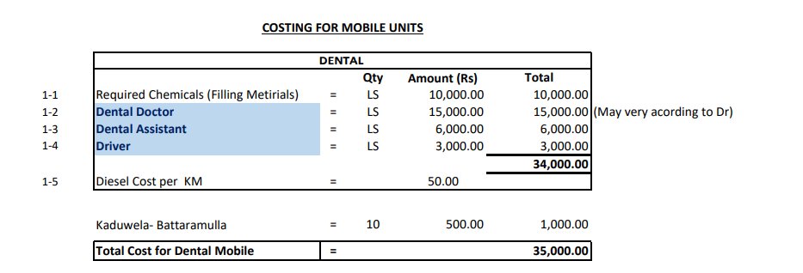

Apart from above costing we paid additional 7000.00 totalling doctor cost 22,000.00. Hence Total cost is 42,000.00