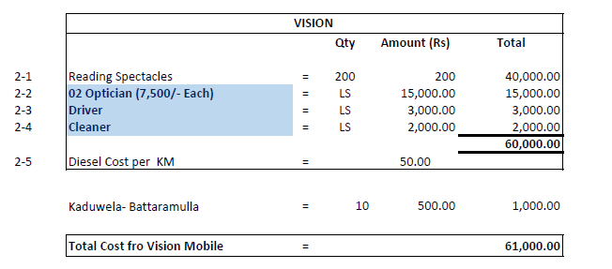

Except for Reading Spectacles we paid for rest totalling 21,000.00